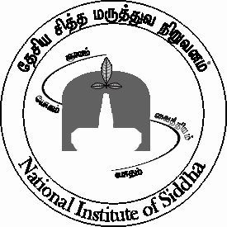**राष्ट्रीय सिद्धा संस्थान / NATIONAL INSTITUTE OF SIDDHA**

**आयुष मंत्रालय / MINISTRY OF AYUSH**

**भारत सरकार / GOVERNMENT OF INDIA**

ताम्बरम सनटोरियम / TAMBARAM SANATORIUM

चेन्नई -600 047 / CHENNAI -600 047

फ़ोन / Tele : 044-22411611 फैक्स / Fax : 044-22381314

ईमेल: [nischennaisiddha@yahoo.co.in](mailto:nischennaisiddha@yahoo.co.in) वेब/Web : [www.nischennai.org](http://www.nischennai.org/)

मिसिल संख्या /File No. NIS/4-9/Internship/2021 तारीख / Date: 06.08.2021

सेवा में / To

विषय / Sub: Internship Training Programme for BSMS students – applications – inviting of – reg.

----

महोदय/ महोदया, Sir/Madam,

This Institute proposes to start the Compulsory Rotatory Residential Internship (CRRI) Training Programme for the BSMS students with effect from 16.08.2021. The duration of each CRRI session will be 45 days. The fee per session is Rs.5000/- (Rupees Five Thousand Only). The students can select the number of sessions they wish to attend based on which they have to remit the fees. However, the maximum number of sessions a student can select is limited to 4 (Four). The students may join the CRRI programme on any date starting from 16.08.2021 and their session of 45 days will start from their respective dates of joining.

In this connection, you are hereby requested to kindly depute the BSMS students of your college/Institute, who have been awarded provisional BSMS degree, for undergoing the CRRI programme. The format of application and the rules and regulatory guidelines in this regard are attached herewith.

The details in this regard are also available in the Institute’s website [www.nischennai.org](http://www.nischennai.org/).

भवदीया,/ Yours faithfully,

Sd/-

प्रो.(डॉ.)आर.मीनाकुमारी / Prof. (Dr.) R. Meenakumari

निदेशक / Director

Encl: 1. Rules & Regulatory Guidelines for CRRI Training Programme

2. Application Form for CRRI Training Programme